# Vocabulary related to travel, directions, and transportation.

**Airplane:** A vehicle that flies and holds a lot of people. *(noun)*  
**Airport:** A building for use by people who use an airplane for transport. *(noun)*  
**Annual pass:** A ticket which has validity of one year. *(noun)*  
**Automatic doors:** Doors which open by sensor without the need to open them manually.  *(noun)*  
**Baggage:** The items which a person takes with them on a journey. *(noun)*   
**Bicycle:** A metal frame with a seat and wheels used for transport. *(noun)*  
**Bike chain:** An object used to secure a bicycle and prevent theft.  
**Bus:** A large vehicle for carrying many people. *(noun)*  
**Bus lane:** A portion of the road specifically for buses. *(noun)*  
**Bus station:** A building for use by people who use a bus for transport. *(noun)*  
**Buzzer:** A button used to inform the driver to stop. *(noun)*  
**Captain:** The person that controls a ship or airplane. *(noun)*  
**Car:** A small vehicle with four wheels that many people own. *(noun)*  
**Check-in:** An area which deals with customer documents prior to travelling. *(noun)*  
**Child seat:** A seat designed for children for the purpose of safety and for use in a car or on a bicycle. *(noun)*  
**Coach:** A large vehicle for carrying many people, like a bus but for long journeys. *(noun)*  
**Commute:** The act of travelling from a fixed location to another destination regularly. *(verb)*  
**Crew:**The people who work on board a plane or ship. *(noun)*  
**Cruise:** A journey taken on a ship to many different countries within a certain period of time. *(noun)*  
**Customs:** An area which carries out security checks in an airport or on a border. *(noun)*  
**Customs officer:** A person who carries out security checks in an airport or border. *(noun)*  
**Cycle lane:** A portion of the road which is only for the use of cyclists.  *(noun)*  
**Cycle path:** A concrete surface used specifically by bicycles. *(noun)*  
**Declare:**An act of informing customs of the items being carried. *(noun)*  
**Delay:** When a method of transport is not running to the time originally anticipated.  *(noun)*  
**Depart:** To move from a place where a person is currently situated. *(verb)*  
**Departure gate:** An exit which enables travelers to enter an airplane. *(noun)*  
**Direct:** To travel to a destination without making any stops. *(adjective)*  
**Disembark:** To get off a ship. *(verb)*  
**Dock:** A place where ships arrive to and leave from. *(noun)*  
**Domestic:** A journey which takes place in the same country. *(adjective)*  
**Driver:**A person who operates a vehicle. *(noun)*  
**Emergency exit:**A door which when opened allows a person to leave an enclosed space safely.  *(noun)*  
**E-ticket:** A piece of paper containing pertinent details regarding a journey.  
**Fare:**The total cost of a journey. *(noun)*  
**Ferry:** A small boat used to carry people or vehicles short distances. *(noun)*  
**Flight:** The act of an airplane making its way to its destination. *(noun)*  
**Helicopter:**A vehicle that flies and does not hold a lot of people. *(noun)*  
**Helmet:** A piece of hard shaped material placed on the head for protection. *(noun)*  
**Hire/rent:**The act of borrowing a vehicle for a certain period of time. *(verb)*  
**Immigration:**An area of the airport or border which requires documents to be checked. *(noun)*  
**Indirect:**A journey which requires a stop prior to arrival at the destination. *(adjective)*  
**Insurance:** A policy which protects the finances of the traveler for health and other purposes. *(noun)*  
**Lorry:** A vehicle for carrying a large amount of goods (US – Truck). *(noun)*  
**Meter:**An electronic display which calculates the total distance travelled as a cost. *(noun)*  
**Motor-bike:**A two wheeled vehicle that has an engine. *(noun)*  
**One-way:**A ticket that allows for the traveler to reach the destination but not to return. *(adjective)*  
**Passengers:** The people who use a mode of transport controlled by another person. *(noun)*  
**Passport:**An important document necessary for travel. *(noun)*  
**Pick-up truck:**A small vehicle with space to carry goods at the back. *(noun)*  
**Pilot:**The person who controls an airplane. *(noun)*  
**Platform:**An area for people to wait for a train. *(noun)*  
**Priority seating:** An area reserved for disabled people or those with small children. *(noun)*  
**Railway:**The system of tracks that trains use to get from one place to another.  *(noun)*  
**Round-trip:**A journey going from and returning to the same place. *(noun)*  
**Runway:**A long strip of concrete used by airplanes when taking off and landing. *(noun)*  
**Safety belt:** A long piece of strong thin material used to secure people in a vehicle. *(noun)*  
**Sidecar:** A small hollow cart attached to the side of a motorcycle for transporting people. *(noun)*  
**Sky train:**A train that is driven above ground level on a suspended track. *(noun)*  
**Take-off:**When an airplane leaves the ground to begin flying through the sky. *(verb)*  
**Tariff:**An amount of money to be paid for the transport service. *(noun)*  
**Taxi stand:**An area for people to book and wait for a taxi. *(noun)*  
**Ticket:**A piece of paper or card used as documentation to allow travel. *(noun)*  
**Ticket counter:**A service desk which sell tickets or deals with ticket enquiries. *(noun)*  
**Ticket inspector:** A person who checks passenger’s tickets for validity. *(noun)*  
**Ticket machine:**An electronic device which enables customers to purchase tickets. *(noun)*  
**Tracks:**The metal runners that direct a train. *(noun)*  
**Train:**A vehicle that travels on a railway tracks. *(noun)*  
**Train station:**A building used to receive people who travel by train. *(noun)*  
**Tram:** A vehicle that follows tracks and travels within a city, usually along the roads. *(noun)*  
**Transfer:** An act of changing transportation before arriving at the destination. *(verb)*  
**Transit:** An act of waiting at another location for the next leg of the journey. *(verb)*  
**Traveller:** A person who moves from one place to another in a short space of time (US – Traveler). *(noun)*  
**Truck:**A vehicle for carrying a large amount of goods (UK – Lorry). *(noun)*  
**Underground:** A train that travels under the ground through tunnels.  *(noun)*  
**Unicycle:** A bicycle that only has one wheel. *(noun)*  
**Van:**A vehicle for carrying a small amount of goods. *(noun)*  
**Vehicle:**A form of transport for carrying people of goods. *(noun)*

Some tourist spots include

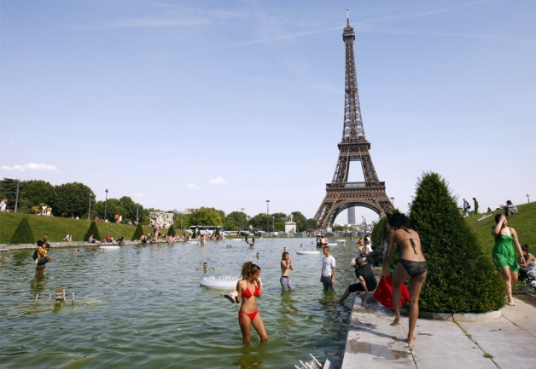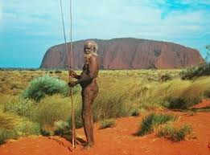

**D**

**H**

**G**

The Effiel towers, Paris

Ayers Rock, Australia

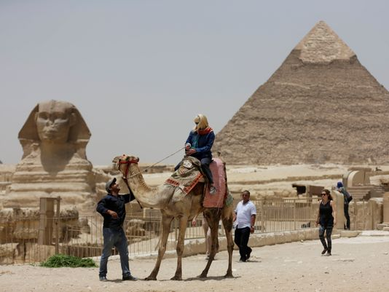

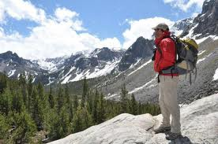

The Pyramids, The Sphinx, Egypt

The Alps

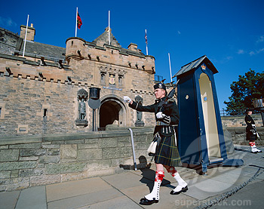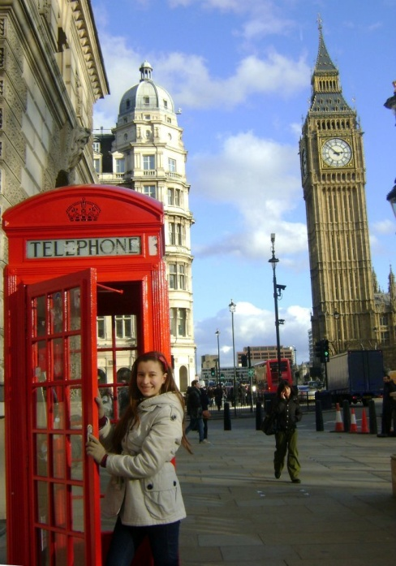

The Edinburgh castle, Scotland

Big Ben and the Houses of Parliament, London

The Copacabana Beach, Rio de Janeiro, Brazil

Venice, Italy

The Statue of Liberty, New York

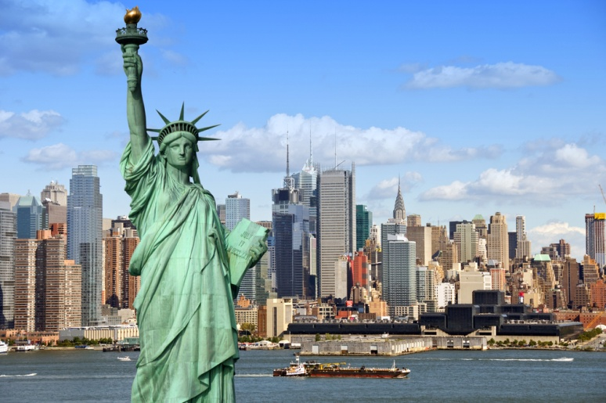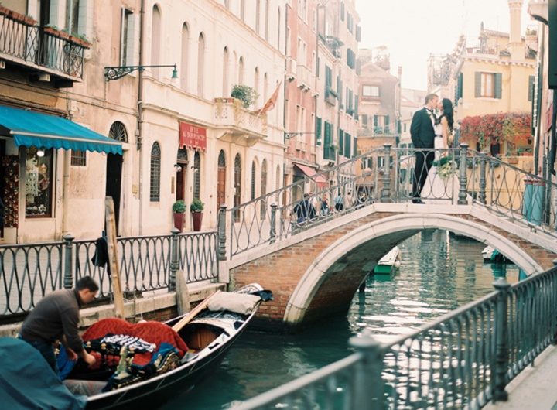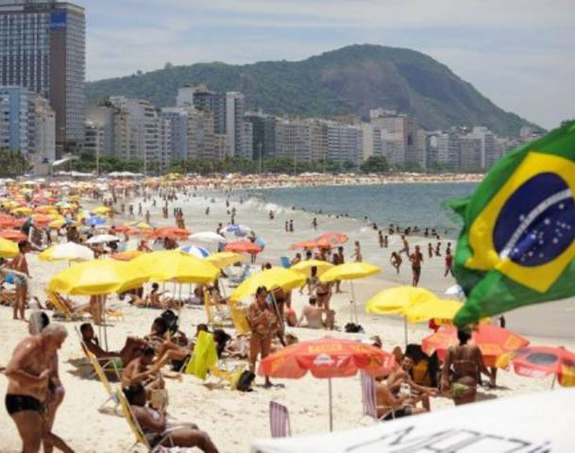

# travel announcements and instructions.

It is very important to listen to announcements.

Let’s listen to an example passage.

Can I have your attention please? This is Mark Brunnell from the campus transportation office. We'd like to remind all students that effective Monday, November 12th, the university campus connector is going back to its original route down Main Street toward the Madison Park Campus. The original route was changed two months ago due to Main Street construction. Now that most of the work is complete, the campus connector will be more efficient for riders, and will have stops in more practical locations for students traveling between campuses. Please note that the route will no longer service the Fourth Avenue corridor, and the stop between 8th and 9th avenues at Marshall Street will be removed. New stops have been added near the School of Business and the School of Engineering. Service hours will remain the same -- 6:30 a.m. to 2 a.m. Monday through Friday, and 10 a.m. to 9 p.m. on weekends. Maps of the new campus connector route are available at the student center, and also on the campus website. If you have any questions about this change, please contact transit coordinator at 555-2421, or e-mail Thank you.

**Bus announcement on the screen.**

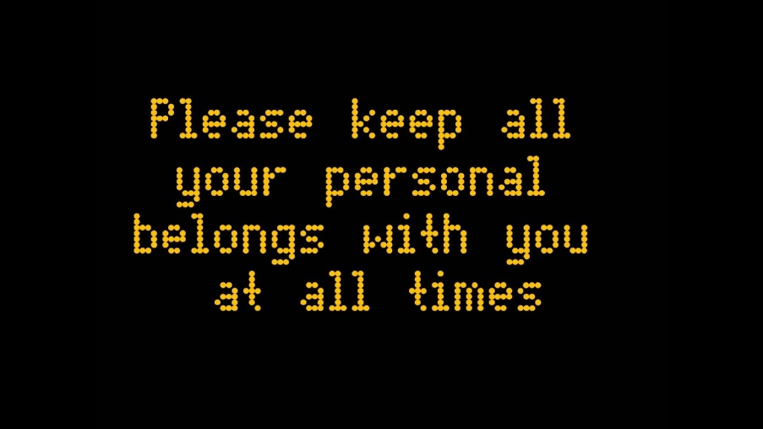

**Pre-boarding Announcement**

Good afternoon passengers. This is the pre-boarding announcement for flight 89B to Rome. We are now inviting those passengers with small children, and any passengers requiring special assistance, to begin boarding at this time. Please have your boarding pass and identification ready. Regular boarding will begin in approximately ten minutes’ time. Thank you.

**Safety Briefing**

Ladies and gentlemen, on behalf of the crew I ask that you please direct your attention to the monitors above as we review the emergency procedures. There are six emergency exits on this aircraft. Take a minute to locate the exit closest to you. Note that the nearest exit may be behind you. Count the number of rows to this exit. Should the cabin experience sudden pressure loss, stay calm and listen for instructions from the cabin crew. Oxygen masks will drop down from above your seat. Place the mask over your mouth and nose, like this. Pull the strap to tighten it. If you are traveling with children, make sure that your own mask is on first before helping your children. In the unlikely event of an emergency landing and evacuation, leave your carry-on items behind. Life rafts are located below your seats and emergency lighting will lead you to your closest exit and slide. We ask that you make sure that all carry-on luggage is stowed away safely during the flight. While we wait for take off, please take a moment to review the safety data card in the seat pocket in front of you.

**Let’s look at this dialogue**

I was walking through the airport to Gate 11 to catch my flight when I heard this announcement:

“**Attention** passengers on English Air flight 232 to Boise. The **departure gate**has been changed. The flight will now be leaving from Gate 26.”

That was my flight! I looked at the **flight information monitors,** turned around, and walked in the **opposite direction.** As I was **approaching** Gate 26, there was another announcement:

“This is an announcement for passengers on flight 232 to Boise. The flight has been **delayed** due to bad weather conditions. The **flight crew** has arrived at the gate, but the **ground crew** is still **de-icing** the **wings** of the **aircraft.** Our new **departure time**is 10:50 AM.”

I thought the **gate agent** was done, but she had another announcement to make:

“I’m afraid that flight 232 is **overbooked.** We’re looking for passengers who are willing to take a later flight in exchange for a **travel voucher worth** $300. Any passenger who is interested should see an agent at Gate 26.”

Oh, no, I thought. I hope I don’t get **bumped** from this flight. Fortunately, a few minutes later, I heard this. It was **music to my ears.**

“We are now ready for **boarding.”**