# Enhancing speaking skills by incorporating idiomatic expressions into conversations.

As you continue to learn more about English, you could become confused when you come across strange expressions that simply don't make sense. It's possible for one of your buddies to exclaim, "It's raining cats and dogs!" However, once you glance up at the sky, all you can see is water and no domesticated animals!

These phrases are known as idioms

*Idioms are expressions that people use frequently in conversation.* Despite not making literal sense, they improve our conversation. We are able to communicate our feelings through use of idioms

## Idioms

1. 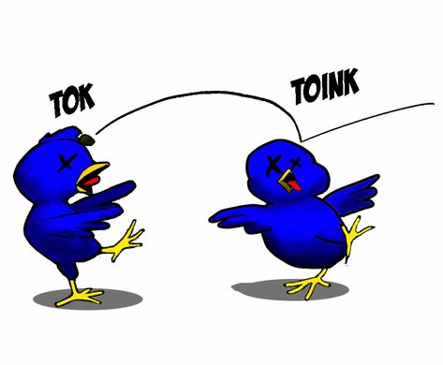**“Kill two birds with one stone.”**

This means to accomplish 2 different tasks at the same time

For instance: pass by the bank to withdraw some cash on your way to the market to get fruits.

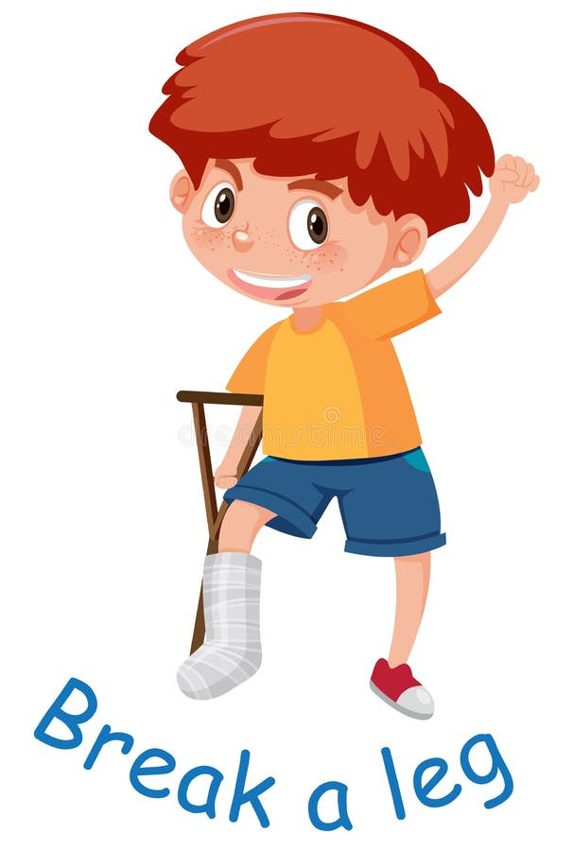

1. **“Break a leg”**

This is used to wish someone good luck!

For instance:

Do you have drama practice today? Break a leg!

1. **“Hit the hay.”**

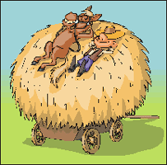This means that one is tired and would like to go sleep

For instance:

Its late guys, I’m going to hit the hay now.

1. **“Stabbed in the back”**

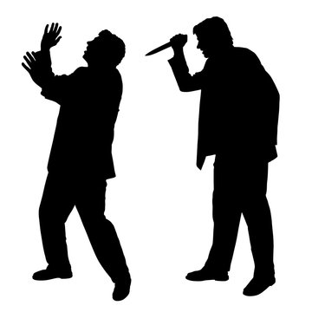It means to be betrayed by someone.

Example:

She stabbed her friend in the back.

1. **“Piece of cake”**

This means that something is easy

For example: cooking is a difficult for me but farming is a piece of cake.

Study the following idioms

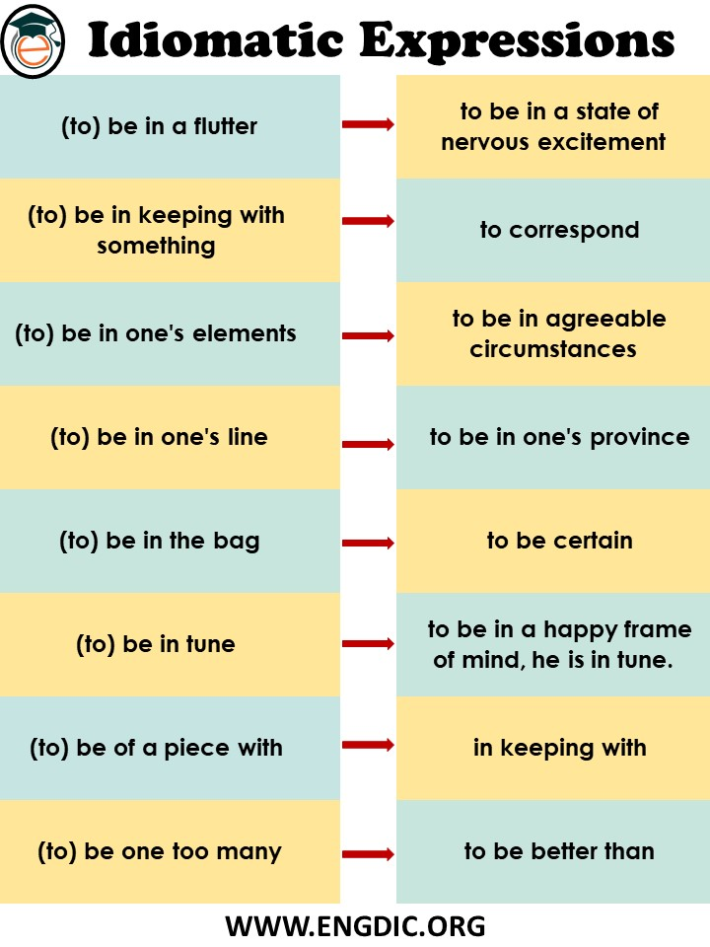

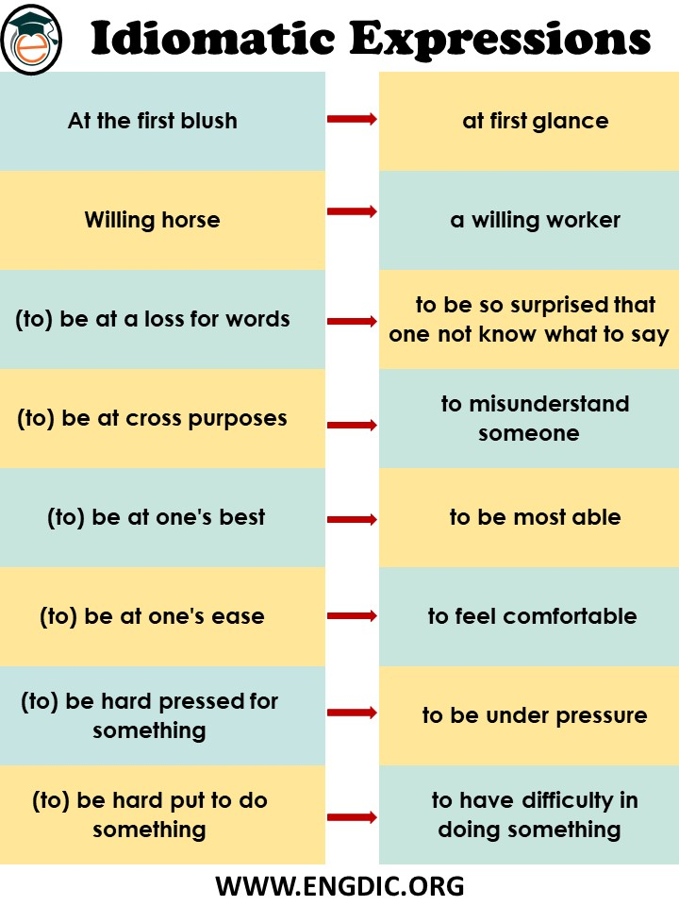

Test yourself

Write sentences using the following idiom

For example: *Once in every blue moon* do you fail to succeed.

1. Willing horse ……………………………………………………………………………………………………………
2. Piece of cake ……………………………………………………………………………………………………………
3. In tune …………………………………………………………………………………………………………………….

## Read the following conversations and try to follow along.

### Conversation 1

Hi! How are you?

I expected you to call me yesterday.

Hi! I’m fine, sorry I was swapped with work yesterday

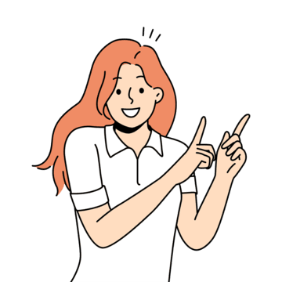



### Conversation 2

How did you think of the test we did?

It was a piece of cake. I will definitely pass it.





I burned the midnight oil yesterday studying. I hope I perform well too



### Conversation 3

How was your day at the cinema?

Okay, though I bought a drink at the cinema but it was a total rip-off.





# Improve reading comprehension by understanding idioms in context.

### Comprehension 1

**Odd Man Out**

I recently watched a documentary called Odd Man Out. It was about a man named Bob who decided to live out of his suitcase. Bob had a little money socked away, so he didn't have to live from hand to mouth. I found the reasons for his decision to throw in the towel and become free as a bird compelling. In any case, Bob had been working for over twenty years for a corporation. While he had been successful at his job, and had made plenty of hay while the sun was shining, he still felt he was tilting at windmills. "I mean," he said to himself "how hard can it be to strike out on your own and live off the fat of the land?" The more he pondered the idea the more he came to realize that he wasn't able to see the forest for the trees. Certainly, he never questioned the powers that be, but he did wonder if things might be a bit more interesting if he gave living by the seat of his pants a go.

Bob was very careful not to let on what he was thinking to anyone until he got all his ducks in a row. He knew that such a decision couldn't be made on the spur of a moment. Things could go terribly wrong in the twinkling of an eye. "No," he thought to himself "I need a plan." It was then he remembered his grandfather Bill. Bill was salt of the earth. He never cared too much for the "finer things in life", as he liked to call them. Bill repeatedly told Bob that tagging along with everyone else would eventually get boring. Bill made his living as a jack-of-all-trades. Sure, he never had money to burn, but he managed to get by. More importantly, Bill was content, and never worried about what others were saying or who he had to impress to get promoted. In any case, these memories of Bill came flooding back as Bob began to to prepare to get a new lease on life.

Finally, the big day arrived and Bob announced that he was stepping down as manager. His colleagues were incredulous: "How can you throw all you've worked for down the drain?" they commented. "He's lost his marbles" commented others. However, Bob was in the the prime of life and he was ready for adventure. He walked out the door and never looked back. Who knows where he is and what he's doing today, but my guess is that he's happy - if not wealthy.

**Idioms Used in the Story**

1. ***sock away*** = to save money
2. ***live from hand to mouth*** = to live with just enough money to survive
3. ***live off the fat of the land***= to life from the products of nature
4. ***make hay while the sun is shining***= earn money and save while you have the opportunity
5. ***in the twinkling of an eye*** = instantly, immediately
6. ***as free as a bird***= completely free and without responsibilities
7. ***get one's ducks in a row*** = to do all the necessary preparations in order to do something
8. ***salt of the earth*** = simple, honest person without pretensions
9. ***on the spur of the moment*** = deciding something without thinking about it
10. ***by the seat of one's pants*** = improvising and learning as you go
11. ***money to burn*** = money to waste
12. ***the powers that be***= phrase used to speak about those in power
13. ***tag along***= to follow or go with others
14. ***throw in the towel***= to quit
15. ***jack-of-all-trades***= person who does many different types of jobs
16. *not able to see the forest for the trees* = become so focused on details that you lose knowledge of the more important things in life
17. ***tilt at windmills***= to work on things or dedicate oneself to impossible tasks
18. ***get a new lease on life*** = to develop a new attitude towards life
19. ***the prime of life***= the best period of one's life
20. ***throw something down the drain*** = to waste something
21. ***lose one's marbles*** = to go crazy

Test yourself

1. He's a smart man because he has ____________ a lot of money for his retirement.
2. socked
3. hidden in offshore accounts
4. socked away
5. Too many people around the world have to ____________________. It's horrible!
6. wear clothes
7. watch reality TV
8. live from hand to mouth
9. I'm sure you'll feel _________________ once you graduate from college.
10. free as a bird
11. slippery as an eel
12. cheap as a miser

### comprehension 2

Young and Free: Prerequisite for Success

Let's face it: In today's business world you need to be young and free of attachments to strike it rich. It's a dog eat dog world out there and you're going to have to work quite a lot. Of course, not only will you have to work quite a lot, you'll need to be flexible and ready to take advantage of anything. That's where the "free" part comes in.

I've got a young friend, he's only 25, but he fits the bill perfectly. He's single and he's hungry. He's willing to start from scratch and, best of all, he isn't afraid of putting his nose to the grindstone for those 80 hour weeks. He decided to take the bull by the horns by going starting up his own business. He found a software developer who knew the internet inside out. This young man was also very ambitious. He left his safe job at the drop of a hat. They were both reaching for pie in the sky, and they were ready.

They also were lucky. They founded a startup and got into the whole social networking business in 2002. In other words, they were early birds and they were willing to sink or swim. Probably the most important ingredient in their success was that they were willing to play things by ear. They kept their ears to the ground, moved full steam ahead and drove hard bargains. Soon, their business was growing by leaps and bounds. Of course, they had some stumbling blocks along the way. Who doesn't? Still, they got the jump on the competition and by the year 2008, they were multi-millionaires. This sort of success for the young and free now has copycats around the world.

Idioms Used in the Story

* **at the drop of a hat** = immediately
* **by leaps and bounds** = very quickly (used with improvement.
* **copycat** = someone or a company who tries to do things like another person or company.
* **dog eat dog** = very competitive
* **drive a hard bargain** = to make a business deal that is very advantageous for you
* **early bird** = someone who takes early advantage of a situation
* **fit the bill** = to have the right characteristics for something
* **full steam ahead** = to continue with full commitment
* **get the jump on someone** = to get the advantage over someone by starting early
* **have one's ears to the ground** = to pay attention to rumors, news, and industry insiders
* **know something inside out** = to have expert knowledge about something
* **pie in the sky** = something very hard to achieve, a dream
* **play something by ear** = to improvise in a situation, react to a situation as it occurs
* **put one's nose to the grindstone** = to work hard and put in many hours
* **sink or swim** = succeed or fail
* **start from scratch** = to start from the beginning
* **startup** = a small company that begins to do business, usually in technology
* **strike it rich** = to become rich, often by creating a new product or service successfully
* **stumbling block** = a difficulty or hurdle that stands in the way of success
* **take the bull by the horns** = to confront a problem and deal with it

Test yourself

1. I think Peter ______________. He's perfect for the job.
2. It's _____________ on the project. We have no time to waste.
3. Our business has grown _________________. We're very happy.
4. I'm afraid I think that idea is ______________. It will never work.

# Using idiomatic expressions appropriately.

**The most common English idioms**

| **Idiom** | **Meaning** | **Usage** |
| --- | --- | --- |
| A blessing in disguise | a good thing that seemed bad at first | as part of a sentence |
| A dime a dozen | Something common | as part of a sentence |
| Beat around the bush | Avoid saying what you mean, usually because it is uncomfortable | as part of a sentence |
| Better late than never | Better to arrive late than not to come at all | by itself |
| Bite the bullet | To get something over with because it is inevitable | as part of a sentence |
| Break a leg | Good luck | by itself |
| Call it a day | Stop working on something | as part of a sentence |
| Cut somebody some slack | Don't be so critical | as part of a sentence |
| Cutting corners | Doing something poorly in order to save time or money | as part of a sentence |
| Easy does it | Slow down | by itself |
| Get out of hand | Get out of control | as part of a sentence |
| Get something out of your system | Do the thing you've been wanting to do so you can move on | as part of a sentence |
| Get your act together | Work better or leave | by itself |
| Give someone the benefit of the doubt | Trust what someone says | as part of a sentence |
| Go back to the drawing board | Start over | as part of a sentence |
| Hang in there | Don't give up | by itself |
| Hit the sack | Go to sleep | as part of a sentence |
| It's not rocket science | It's not complicated | by itself |
| Let someone off the hook | To not hold someone responsible for something | as part of a sentence |
| Make a long story short | Tell something briefly | as part of a sentence |
| Miss the boat | It's too late | as part of a sentence |
| No pain, no gain | You have to work for what you want | by itself |
| On the ball | Doing a good job | as part of a sentence |
| Pull someone's leg | To joke with someone | as part of a sentence |
| Pull yourself together | Calm down | by itself |
| So far so good | Things are going well so far | by itself |
| Speak of the devil | The person we were just talking about showed up! | by itself |
| That's the last straw | My patience has run out | by itself |
| The best of both worlds | An ideal situation | as part of a sentence |
| Time flies when you're having fun | You don't notice how long something lasts when it's fun | by itself |
| To get bent out of shape | To get upset | as part of a sentence |
| To make matters worse | Make a problem worse | as part of a sentence |
| Under the weather | Sick | as part of a sentence |
| We'll cross that bridge when we come to it | Let's not talk about that problem right now | by itself |
| Wrap your head around something | Understand something complicated | as part of a sentence |
| You can say that again | That's true, I agree | by itself |
| Your guess is as good as mine | I have no idea | by itself |