# Review present, past, and future tenses and their usage.

The past, present, and future are the **central divisions** of time in English. The *present* represents *actions happening now,* while the *past* represents *actions that happened earlier*, and the *future* describes *actions that will happen later.*

Simple tense

The past, present, and future tenses in their standard, unadorned forms are referred to as the simple tense in grammar. It doesn't add any fresh information, in contrast to the other elements.

Simple tenses are the simplest to produce and contain the fewest restrictions, as their name suggests.

Perfect tense

The perfect tense has a slightly more complex definition. It is used to ongoing or completed acts that have a connection to different times in time.

The perfect tense, for instance, shows that the action continued in the past and is currently occurring in the line I've played basketball since I was a kid.

Continuous tense

We use the continuous tense for ongoing actions or actions that happen a while before completion. For example, *they are working all weekend* means the work lasts many hours before it’s done

Perfect continuous tense

When you combine the perfect and continuous tenses, you get the perfect continuous tense.

For example: she has been looking for a job for a year now before she got an interview.

Note

**Base Form** – V1’

?

**Past Simple** – V2

**Past Participle** – V3

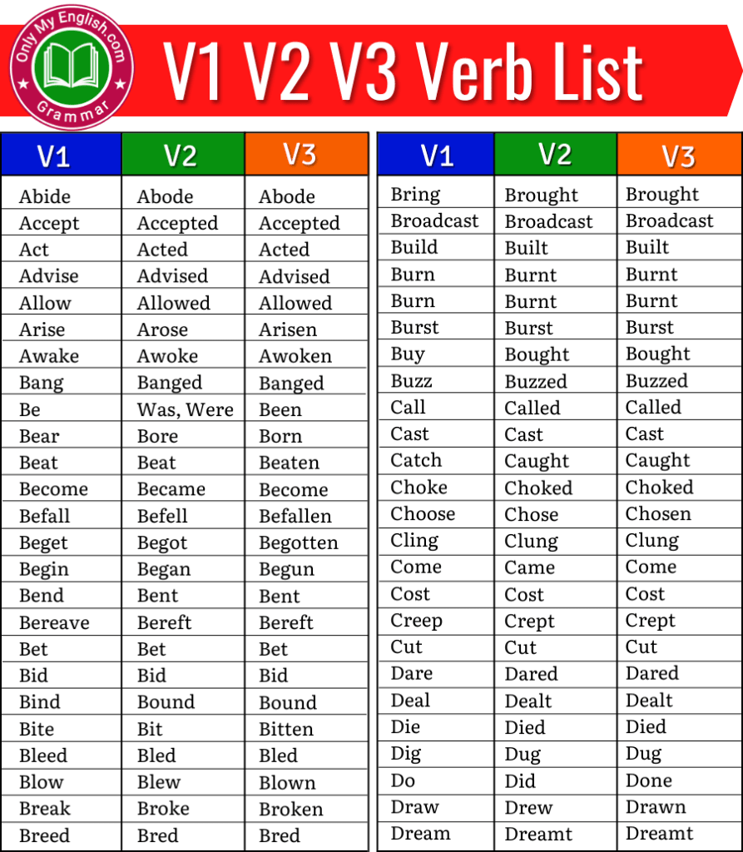

Example sentences

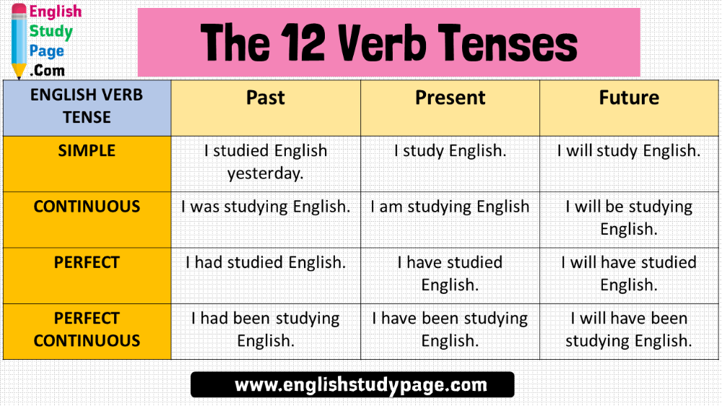

Test yourself

Write a sentence using the following words in the correct specified tense

|  |  |  |  |
| --- | --- | --- | --- |
| **Verb** | **Present tense** | **Past tense** | **Perfect future continuous** |
| 1. Walk | …………………………………..  ………………………………….. | I walked to school yesterday | …………………………………….  ………………………………….. |
| 1. Study | …………………………………..  ………………………………….. | …………………………………..  ………………………………….. | I will be studying Spanish. |
| 1. Swim | ………………………………….. | ………………………………….. | …………………………………..  ………………………………….. |
| 1. Watch | …………………………………..  ………………………………….. | …………………………………..  ………………………………….. | …………………………………..  ………………………………….. |
| 1. Begin | …………………………………..  ………………………………….. | …………………………………..  ………………………………….. | …………………………………..  ………………………………….. |

She _________ food when the guests arrived yesterday.

a.) preparing                   b.) was preparing

c.) is preparing              d.) has been preparing

# Practice in forming affirmative, negative, and interrogative sentences.

Verbs in English come in three main categories:

**The affirmative**= asserting that something is true or valid.  
**The negative**= a reply denying something.  
**The interrogative**= asking a question.

Study the table below

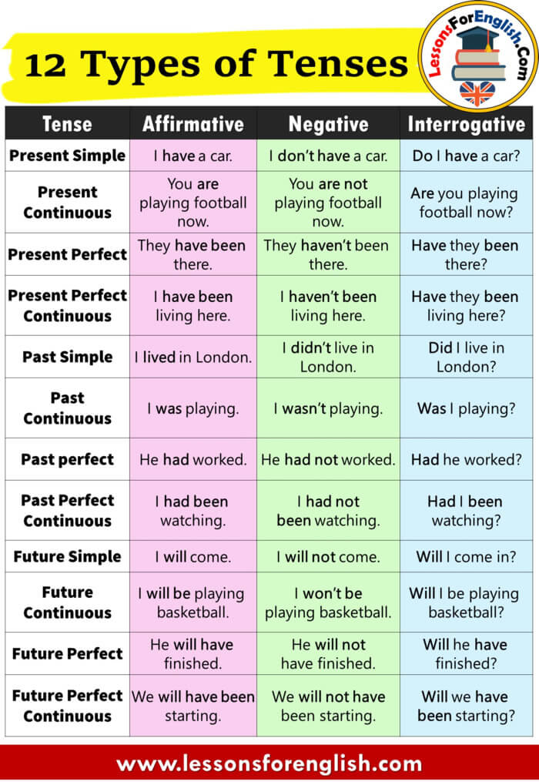

The following statements are affirmative. Write them in the interrogative

For example:

He will be travelling.

*Will he be travelling?*

1. It would work

………………………………………………………………….

1. She is reading.

………………………………………………………………….

1. I cooked dinner.

………………………………………………………………….

1. The child is riding a bicycle

………………………………………………………………….

1. The teacher is writing on the board

………………………………………………………………….