Introduction to language and culture

# Basic pronunciation and phonetics

The English phonetic system has four components: syllabic word structure, speech sounds, intonation and stress. It simply describes the way we perceive and produce the sounds of speech.

The 44 phonetic sounds are:

* Set 1: s, a, t, p.
* Set 2: i, n, m, d.
* Set 3: g, o, c, k.
* Set 4: ck, e, u, r.
* Set 5: h, b, f, ff, l, ll, ss.
* Set 6: j, v, w, x.
* Set 7: y, z, zz, qu.
* Consonant digraphs: ch, sh, th, ng.
* Vowel digraphs: ai, ee, igh, oa, oo, ar, or, ur, ow, oi, ear, air, ure, er, ay, ou, ie, ea, oi, ir, ue, wh, ph, ew, aw, au, oe, a-e.

In order to learn this phonetics with ease, one should make a list of vocabulary words written in IPA and try to sound out each word, paying attention to both the vowel symbols and consonant as well as other special symbols, like suprasegments and diacritics. You can also strengthen your knowledge more by writing out words you are conversant with phonetically. Note that suprasegmentally phonetics is those whose domain is the larger units of connected speech: words, syllables, texts and phrases.

**Summary**

* Phonetics is the study of the variety of sounds which happen in speech, including the way they are produced by the speech organs and their acoustic properties.
* Pronunciation is the way of producing a spoken word, particularly so that it is acknowledged or generally understood.

Some few examples of phonetic words with a variety of vowel sounds are:

* Fleece, pain, stay, sway, beep, party, tree etc.

Some words are spelt precisely how they sound. For example, the letter ‘T’ uses one sound. When you sound the word tree, you can hear the letter ‘T’ sound, creating one simple sound.

Nevertheless, things get a little tricky when the ‘T’ is paired with other letters such as ‘th’ words, as it loses the simple sound and creates a different sound. The new sound ‘th’ words create don’t create a singular sound and in certain words such as thin and this, the single letter of ‘T’ doesn’t correlate to one sound, making it a little trickier to spell.

## Examples of phonetic words with different consonant sounds

**Sound/letter Example**

b bad, but

ch cheek, cheese or nature

d dog, do

f food, fur, enough

g bug, go

h ahead, hop

l letter, leg

m mom, man

m tin note the “n” at the end, no

ng sing, ring

p tip note the “p” at the end, pen

r run, far – “r” is heard at the far end as you pronounce it

ss/s pass, see

Sh She

th teeth, the

v have, visit

w we

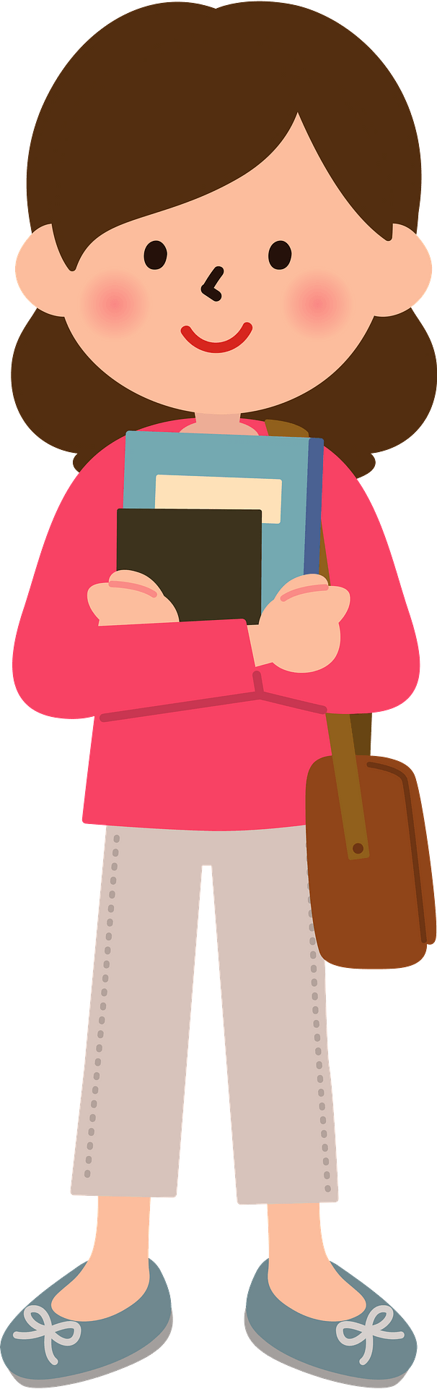**Phonetic words with different vowel sounds are like:**

u bun, gum

ow mouth

ou out, count

oo boot, food

oe poem, shoe

o toast, lot

a cat, hat

ar party, start

er burger, letter

The above words sound out different letters to how they’re spelt.

# Common English (UK) greetings and introductions

Understanding the UK culture is a must for anyone visiting or staying in the UK.

Greetings and introductions happen to be the ice breaker otherwise if you are new to the UK culture, the situation can turn to be really awkward. If things didn’t turn out right, it would leave you feeling very embarrassed and that is why you have to get it right straight away. In the past the British people would introduce themselves to new people with a handshake then continue to ask “how do you do”. However, these days the same greetings appear somewhat old fashioned and so the greetings are hardly used.

Be careful that you do not poke people in the eye as you pass a handshake as someone comes in for a kiss or a hug. Kindly note that a handshake is still common especially in formal situations between women and men, between men and between women. But the trick is to know the type of hand shake.

1. The handshake should be confident and firm. Not too tight though as if you proving masculinity.
2. Smile and make eye contact with the other person
3. Two shakes only is what is required! Grasp the hand, shake it up and down twice - up down up down and do not hold on for too long.
4. Hugs, high five and kisses is a reservation for family and very close friends. It is important to note that in the UK, greetings in social places are usually informal.
5. In social introductions, first names are usually asked.

**Introductions in the UK**

Ideally, in social circles, a man is traditionally introduced to a woman. Nevertheless, formal introductions are based on a person's position in an organization. The highest-ranking person is introduced to everyone else in order of their ranking. If you introduce two people of equal rank to each other, introduce the one you are less acquitted with to the one you know well.

**Introducing yourself**

When shaking hands individuals may give you their name without saying "Hello". It can come across as a bit hostile, but it's not considered to be rude. For example: -

I hold out my hand to you and say, "James Bruce."

If you wish to be on first-name terms with someone you can indicate this by stressing your first name: -

"Hello, my name is James. James Bruce."

For example: -

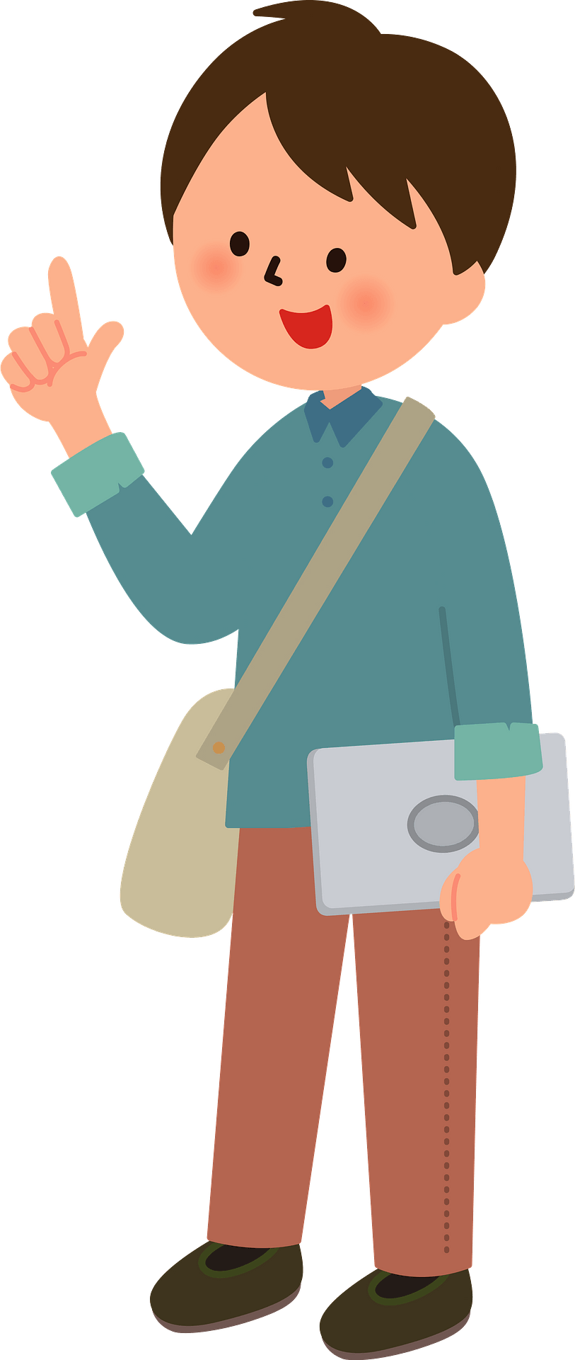

**How to react to an introduction**

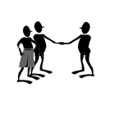

When meeting formally with a person for the first time, you shake their hand and say

"Pleased to meet you."

Or

"How do you do?"

"How do you do?" just means "Hello".

High 5 Young people in social circles sometimes say "Give me five!" and smack their hands together (high five), elbow bump, or a foot nudge are now popular since the outbreak of Covid.

**Examples of Formal greetings and introductions**

|  |  |  |  |
| --- | --- | --- | --- |
| ***Introducing yourself*** | ***Introducing others*** | ***Responding to an introduction*** | ***When leaving*** |
| How do you do? My name is Mrs. Brown | Mrs. Brown, may I introduce my Boss Mr. Alex Timber. | Pleased **to meet you** Mrs. Brown | Goodbye. It is a pleasure to have met you. |
| Hello, Mrs. Hand. I’m the owner of this web site. | Mrs. Hand I’d like you to meet Thomas our sales rep. Thomas this is Mrs. Hand | Pleased to meet you Mrs. Hand | Goodbye. Nice to have met you. |
| Jane. | Jane, meet my husband. George this is my cousin Jane. | Hi, Jane. How are you? | Bye. It was nice to meet you. |

**Informal greetings**

|  |  |
| --- | --- |
| ***Possible Greetings*** | ***Possible responses*** |
| Hello Mary. It’s nice to see you again | What a lovely surprise! How are you? It’s been a while. |
| Good morning Tom. How are you today? | I am very well thanking you. And you? |
| Good afternoon Mrs. Brown. It’s good to see you. | Thank you. It’s nice to see you too. How are you? |
| Hi, Tom. How’s it going | Not too bad, busy as ever |
| Hi. Jose. How are things | OH fine. You know how it is. |

**How to start talking to strangers**

Use the following phrases if you want to start talking to a stranger that you have met.

1. If you do not mind, could you please …
2. Excuse me can you tell which...
3. Excuse me please. Could you show me the way to…?

**Note:**

* Good Morning is reserved for any time before noon.
* Good Afternoon is typically used between 5-6 p.m.
* Good Evening is from 5PM to 12 AM.

# Essential vocabulary related to daily life and social interactions

Traversing the particular foibles in UK is not easy not to mention the intricacies of British social life. If you are new in UK, it would pay to understand the Brits as people as well as their culture. It is not enough though, because getting to know their social interactions would help you adapt in the UK as first as possible.

Get to know the UK etiquette and it will help you integrate well in the country. Some vocabulary that has to be at your fingertips are:

1. **Emotional stability**

British people according to the “insider” magazine, are collected, self-controlled and they really value composure.

1. **Alcohol**

It is also said that most social gatherings in the UK involves alcohol from hikes to study groups! Most socializing happens in the pub hence the alcohol high consumption. Instead of opening up individual tabs as it is mostly done in other countries, friend rotate in buying each other beer.

1. **Weather**

It is a national obsession to talk about the weather in the UK. According to current research, over 90% of British interviewed admitted to having talked about the weather in the last six hours, while 38% said they had in the past one hour. “This means that at almost every minute in UK at least a third of the people is either chatting about the weather, has already done so or is about to speak about it,” says Kate Fox, a social anthropologist.

Due to the UK’s location, it bears the brunt of storms caused by the earth’s rotation

****If they are not talking of the stormy skies, they are talking of the much moisture in the air and actually, the Brits hardly know what to expect at any given time. It is interesting that you can easily get to see snow in summer, people wearing T-shirts in winter. In the UK, the weather is not just ‘good’, ‘bad’, ‘cold’, ‘hot’

1. **Brits do not talk about money casually.**

You will not get to see them talk about salary, debt, bills casually.

1. **Personal space**

In the UK, they hardly pick conversations with strangers like chatting with a cashier, a person sitting next to you etc.

1. **Time**

British people are good time keepers and they usually frown upon late comers.

1. **Queuing**

British people are much disciplined and patient in waiting in line and anyone who tries to jump the queue will be frowned upon.

1. **Smoking**

Cigarette smoking is not uncommon in the UK. In 2007, smoking was banned in all enclosed public areas in England. This includes bars, restaurants and public transport. It’s imperative to check your tenancy agreement to see if smoking is permitted in your space.

1. **Tipping**

Tipping in the UK is common and it is common when it comes to eating in restaurants. Adding a few extra pounds to the bill is standard practice though it is not an obligation.

1. **Manners**

‘Please and thank you’ are some of the most common phrases in the UK and it’s good to use them when appropriate. British people are also famous for over-apologizing! Passing wind, spitting, yawning/sneezing without covering your mouth should be avoided in public.

1. **Mobile phone etiquette**

Put your phone away when talking to someone or eating at the dinner table.

1. **Tea**

A cup of tea is a typical symbol of British culture. You’ll probably be offered tea in most places you visit in the UK. Tea can also mean your evening meal in the UK so bare this is mind!!Breakfast, dinner and tea or breakfast, lunch and dinner are the most common names to describe meals.

## Simple conversations using learned expressions

1. **Fancy a cuppa?**

Meaning: “Would you like a cup of tea?”

Brits love their tea, but nothing can prepare you for the aggressiveness of their addiction. Tea is not just a beverage but a way of life. Whether, visiting friends or you’re at work or simply spending a day at home, if a British person is around, it won’t take long until you’re hear the question: “Fancy a cuppa?”

1. **Alright?**

Meaning: “Hey, how are you?”

Modern-day Brits are definitely less wordy unlike Shakespeare. Long are gone are the days where we would greet each other in the street with a formal “How do you do, Sir?” Nowadays, your average Brit is far more likely to greet their friends or loved ones with a curt “Alright?” This greeting is simply a modern version of “Hello!” The greeter is not asking you for an in-depth explanation of your well-being. An authentic “Alright?” can only truly be achieved if the greeter gives a slight nod of the head, while the word itself is to be voiced as a short groan.

1. **I’m knackered!**

Meaning: “I’m tired.”

This is a great one to break out when you’re catching your breath after a serious amount of physical exercise. Nothing could be more British than running for the bus while holding multiple bags of shopping in your hands. Once you’ve made it aboard, sit down and let your breath out loudly and exclaim, “I’m knackered!”

1. **Cheeky**

Meaning: mischievous, playful

Brits take pleasure in being playful, so they often use the word “cheeky” to describe fun but small, playful activities.

**For example:**

A Brit: “Join us for a cheeky pint!”

Translation: “Come to the pub and have a pint of beer with us!”

“Cheeky” can also be used as an adjective and you’ll frequently hear confident persons labelled as “cheeky,” or “having a cheeky smile” that suggests they’re up to something.

1. **I’m chuffed to bits!**

Meaning: I’m very pleased.

This is an excellent phrase to use: -

When displaying immense pride in one’s own efforts. For example, if you’re about to tuck into a pleasant full English breakfast, then you could say that you’re feeling “chuffed to bits.” Or, perhaps you’ve just won over someone’s heart by introducing them to your favorite game. Then you could now say that you’re “chuffed to bits with yourself.”

1. **Bloody**

Meaning: very

While emphasizing on a certain characteristic or person, then you have got to use the word “bloody.” Have you just finished drinking your favorite wine? Then smack your lips and exclaim that it was “bloody delicious!” Have you just had the misfortune of seeing a terrible show? Then you’ll have to turn to your friend next to you, fuss loudly, and say, “That was bloody horrible, wasn’t it?”

1. **I’m pissed.**

Meaning: I’m drunk.

“To be pissed” means to be very angry about something. In UK, the phrase is used to refer to the feeling of having had too many drinks resulting to the struggle to walk in a straight line.

1. **Lovely**

Meaning: attractive, beautiful

This tremendously popular word conveys a feeling of approval on behalf of the speaker towards a person, and its best summed up in the phrase, “that’s a lovely cup of tea.” However, the word is more popular amongst older women.

*Lady A “Oh! Look at that lovely young lady!”*

*Lady B: “Right! And look how lovely her shoes are!”*

*Lady A: “Yes! They’re lovely!”*

*Or*

*A child draws a picture and shows the mother. The mother will likely exclaim; “It is lovely”.*