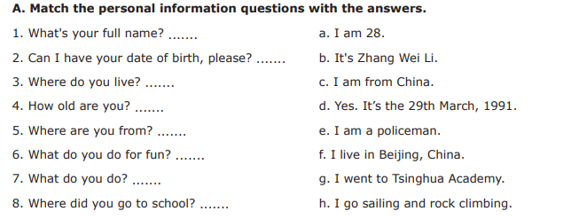

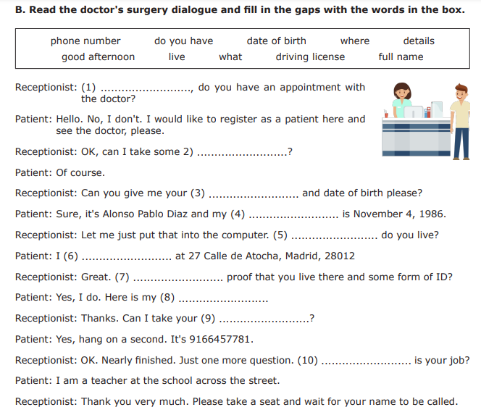

**C. Read the passage and answer the questions that follow in complete sentences**:

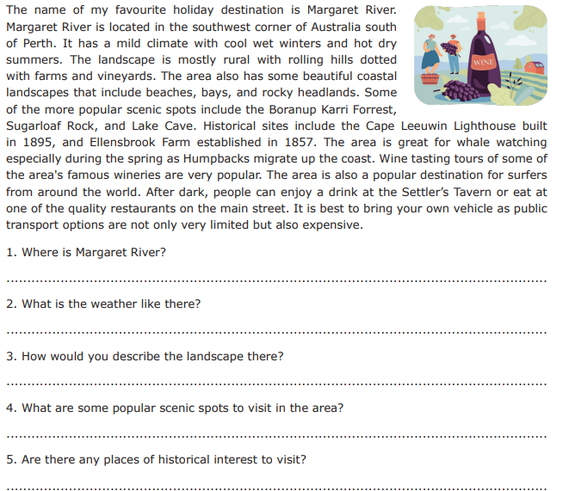

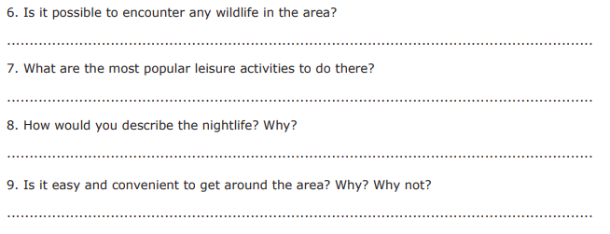

D. Write sentences describing the people in the picture. There are words in the box to help you.

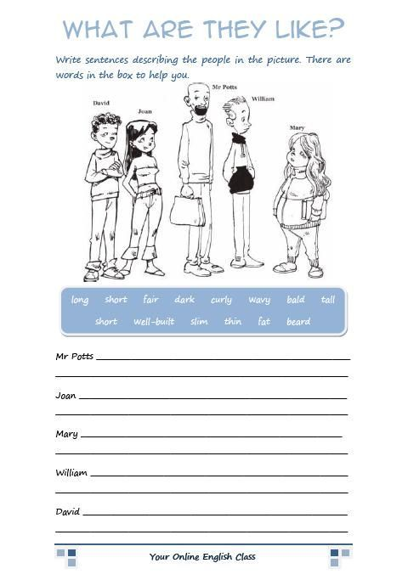

E. **Write short descriptions of the people in the pictures below using the verb *to be* and the adjectives: *tall, short, overweight, slim, old, young*.**

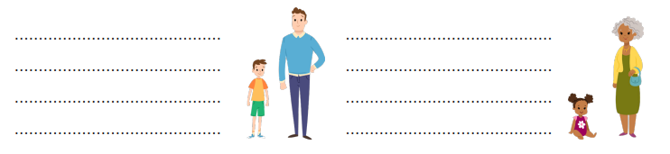

# F. Making Appointments

Instructions:

* Read the following scenarios and answer the questions that follow.
* Use appropriate language and manners when making appointments.

Scenario I:

You want to visit the school library to borrow a book. The librarian is usually busy, so you need to make an appointment to meet her.

Question 1: Who do you need to make an appointment with?

Answer: _______________

Question 2: Write a polite and clear sentence to make the appointment.

Sentence: _______________

Scenario II:

You are feeling unwell and need to see the school nurse. You want to make sure the nurse is available when you visit.

Question 1: Who do you need to make an appointment with?

Answer: _______________

Question 2: Write a polite and clear sentence to make the appointment.

Sentence: _______________

Scenario III:

Your class is organizing a field trip to the local zoo, and you need to speak with your teacher about it.

Question 1: Who do you need to make an appointment with?

Answer: _______________

Question 2: Write a polite and clear sentence to make the appointment.

Sentence: _______________

# G. Giving Directions

Instructions:

* Read the following scenarios and answer the questions that follow.
* Use appropriate language and vocabulary to give directions.

Scenario I:

Your friend is looking for the school cafeteria. Explain how to get there from the school entrance.

Question 1: What is your friend looking for?

Answer: _______________

Question 2: Give step-by-step directions to reach the school cafeteria.

Directions: _______________

Scenario II:

Your classmate needs to find the playground during recess. Describe how to get there from the classroom.

Question 1: What is your classmate looking for?

Answer: _______________

Question 2: Provide clear directions to reach the playground from the classroom.

Directions: _______________

Scenario III:

A visitor is trying to find the school library. Explain how to get there from the main office.

Question 1: What is the visitor looking for?

Answer: _______________

Question 2: Give concise directions to reach the library from the main office.

Directions: _______________