# Shopping

Whether it be a supermarket or a local convenience store, it's vital to prepare yourself for your shopping trip, otherwise, you might just come home frustrated.

Note the following:

* Never shop if you are hungry, tired or thirsty – We will be able to overcome any curious sweet smells in the supermarket because your blood sugar will be well balanced.
* Make a shopping list based on your needs
* Be mindful of the indirect techniques used to influence you
* Decide the amount you want to spend for shopping
* Carpool with a friend going for shopping then you have fun and save money.
* Pick the things that are going out of season. Trust me, they are cheaper.
* Shop on holidays and save some bucks through free offers.
* If you have coupons - use them.
* Enquire days when ‘hot deals’ are offered and shop on those days

Now let’s look at some vocabulary you need to know to help in your shopping experience

# Shopping vocabulary

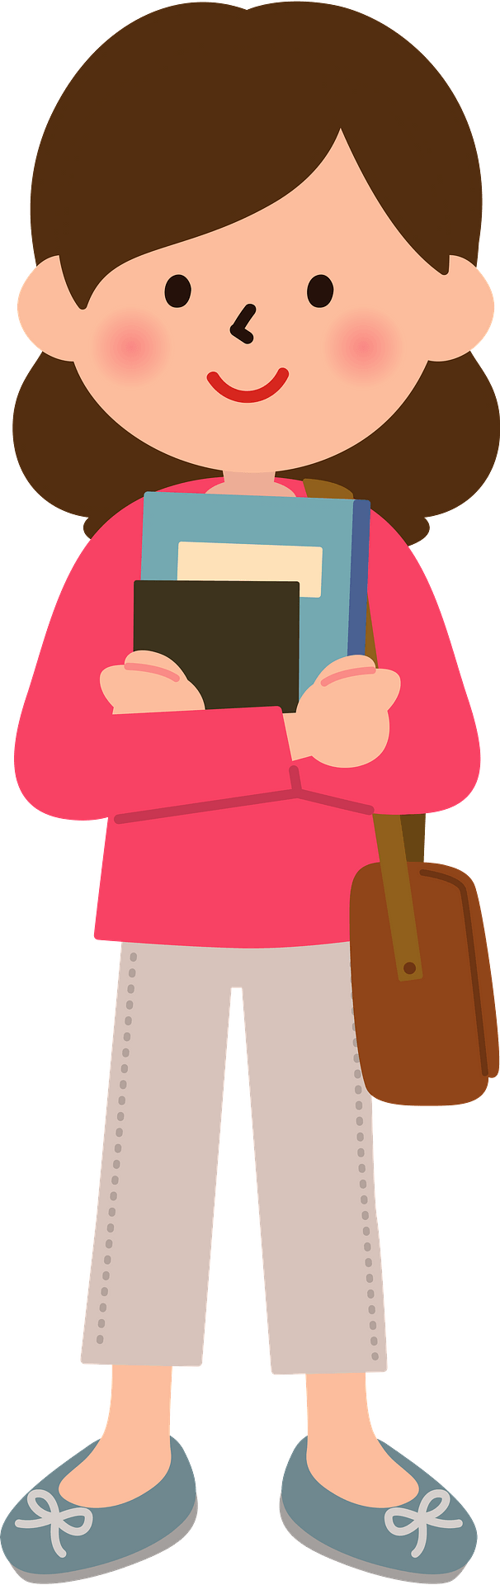**Afford**: To have enough money to purchase an item or pay for a service. *(verb)*  
**Aisle**: A long walkway with items for sale on either side. *(noun)*  
**Bag**: A carrying aid with handles that is usually made from plastic or recycled material. *(noun)*  
**Baggy**: When an item of clothing is excessively loose. *(adjective)*   
**Bakery**: A shop which provides people skilled in preparing and selling pastries, cakes and bread. *(noun)*  
**Bargain**: The price of an item that is considered to be of very good value. *(noun)*  
**Basket**: A hand held square shaped mesh container usually made from either metal or plastic which is used to hold items.  *(noun)*  
**Best before**: The date before which an edible item is most delicious. *(adjective)*  
**Brand**: The name of a product which is often associated with a certain price and quality. *(noun)*  
**Butchers**: A shop which provides people skilled in preparing and selling meat. *(noun)*  
**Buy**: An act of providing payment for goods. *(verb)*  
**Card machine**: A machine which communicates with the customer’s bank for the purpose of paying for goods or services. *(noun)*  
**Cash**: A rectangular piece of paper often known as a note which is used for payment of goods or services. *(noun)*  
**Cashier**: A person who calculates the total cost and receives payment for the goods. *(noun)*  
**Change**: A quantity of money to be returned to the person paying for goods or services usually when payment has been made with bank notes which total more than the amount requested. *(noun)*  
**Cheap**: The cost of something considered to be reasonable and easily affordable. *(noun)*  
**Chemist**: A shop which sells general and personally prescribed medication. *(noun)*  
**Cheque**: A rectangular piece of paper which serves as a method of payment after the amount is written and signed by the account holder. *(noun)*  
**Clearance sale**: A time when most items are reduced, usually due to the shop closing down. *(noun)*  
**Closed**: A time when the product or service is not accessible to customers. *(adjective)*  
**Coin**: A small thin piece of metal which is usually round and used for payment of goods or services. *(noun)*  
**Convenience store**: A shop that is easily accessible to the general public that sells most things. *(noun)*  
**Credit/Debit card**: A rectangular piece of thin plastic often with an electronic chip which is used for paying for goods or services. *(noun)*  
**Customer**: A person who pays for goods or services.  *(noun)*  
**Delivery**: The transportation of items from the shop to the customer’s preferred address. *(noun)*  
**Discount**: A reduction in the original price of a product. *(noun)*  
**Expensive**: The cost of something considered to be excessive or unaffordable. *(adjective)*  
**Faulty**: An item which does not satisfy its description or cannot fulfil its purpose. *(adjective)*  
**Fitting cubicle**: A small room used for changing clothes. *(noun)*  
**Florist**: A shop which provides people skilled in cutting and arranging flowers. *(noun)*  
**Gift voucher**: A rectangular piece of thick paper which represents money and can be used to buy goods to the value printed on its front. *(noun)*  
**Label**: A piece of paper printed with a description and attached to the item. *(noun)*  
**Loyalty card**: A card provided by an establishment similar to the size of a credit card which is often used to collect points which can be exchanged for rewards. *(noun)*  
**Luxury items**: Items which are fashionable but not a necessity. *(noun)*  
**Packaging**: A protective material, usually plastic or cardboard, which surrounds the product prior to purchase. *(noun)*  
**Price**: The monetary value of a particular item. *(noun)*  
**Purchase**: An act of providing payment for goods. *(verb)*  
**Purse**: A container, usually used by women, for holding bank cards, cash and occasionally coins. *(noun)*  
**Quality**: The standard expected of a particular item. *(noun)*  
**Queue**: The act of people standing behind one another to wait for a service. *(noun)*  
**Receipt**: A long slip of paper which details the items bought and provides proof of purchase. *(noun)*  
**Refund**: A return of the price paid which is usually subject to company policy. *(noun)*  
**Sale**: A time where certain items are lowered from their original price. *(noun)*  
**Sales assistant**: A person who ensures a comfortable shopping experience for the customer, usually by serving their needs and informing them of current offers. *(noun)*  
**Scales**: A machine which weighs items to assist with calculating the price of a product. *(noun)*  
**Security tag**: A device securely attached to a product to deter thieves. *(noun)*  
**Self-service**: A machine used by customers to serve and pay for items by themselves. *(adjective)*  
**Shelf**: A horizontal, strong piece of material used for displaying items. *(noun)*  
**Shop**: A designated space which offers goods or services for payment. *(noun)*  
**Shopper**: A person who visits a shop with the intention of buying an item. *(noun)*  
**Stock**: A quantity of a particular product held by a shop. *(noun)*  
**Supermarket**: A large shop with many departments which sells a wide range of items. *(noun)*  
**Till**: A machine used to keep cash received from customers and to provide change if necessary. *(noun)*  
**Trolley**: A large rectangular shaped mesh container usually made from metal which has wheels and is used to hold items. *(noun)*  
**Use by**: The date when an edible item should be consumed by. *(adjective)*  
**Wallet**: A pocket-sized flat container, usually used by men, for holding bank cards and cash. *(noun)*  
**Window shopping**: The act of browsing products without the intention to buy. *(verb)*

# Phrasal Verbs for Shopping

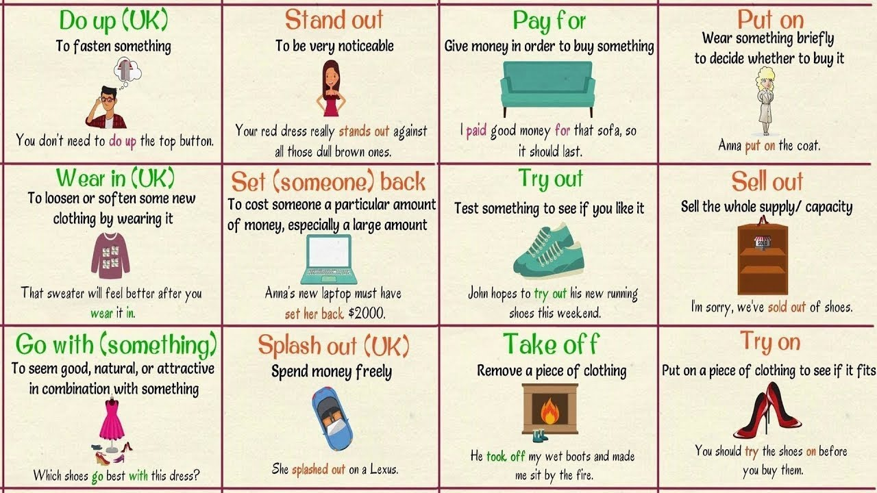

**Pay for**

* **Meaning**: Give money in order to buy something
* **Examples**: *I****paid****good money****for****that car*

**Put on**

* **Meaning**: To see something is worth trying
* **Examples**: *Anna****put on****the shoes.*

**Queue up/line up**

* **Meaning**: Wait for something in a line
* **Examples**: *Some individuals****queued up****all night to get into the store.*

**Ring up**

* **Meaning**: Record an amount of money by pressing buttons on a cash register
* **Examples**: H*e****rang up****all the items on the till.*

**Sell out**

* **Meaning**: Sell the whole supply/ capacity
* **Examples**:*I’m sorry, we’ve****sold out****of phones.*

**Shop around**

* **Meaning**: Compare prices before buying
* **Examples**: *We often****shop around****for the best deal.*

**Take off**

* **Meaning**: Remove a piece of clothing
* **Examples**: *He****took off****my wet boots and made me sit by the fire.*

**Try on**

* **Meaning**: Put on a piece of clothing to see if it fits
* **Examples**: *You should****try****the shoes****on****before you buy them.*

**Try out**

* **Meaning**: Test something to see if you like it
* **Examples**: *John hopes to****try out****his new running shoes this weekend.*

**Pop into**

* **Meaning**: To visit briefly
* **Examples**: *I’m going to****pop into****the store for a moment.*

**Do up**

* **Meaning**: To fasten something
* **Example**: *You don’t need to****do up****the top button.*

**Stand out**

* **Meaning**: To be very noticeable
* **Example**: *Your red dress really****stands out****against all those dull brown ones.*

**Pick out**

* **Meaning**: To choose / select
* **Example**: *Can you help me****pick out****a wedding dress?*

**Wear in**

* **Meaning**: To loosen or soften some new clothing by wearing it
* **Example**: *That sweater will feel better after you****wear****it****in****.*

**Set (someone) back**

* **Meaning**: To cost someone a particular amount of money, especially a large amount
* **Example**: *Anna’s new laptop must have****set her back****$1000.*

**Look out for**

* **Meaning**: To watch or check regularly for something or to search for something
* **Example**: *I always****look out for****deals when I’m shopping.*

**Go with something**

* **Meaning**: To seem good, natural, or attractive in combination with something
* **Example**: *Which shoes****go****best****with****this dress?*

**Splash out**

* **Meaning**: Spend money freely
* **Example**: *She****splashed out****on a house.*

# Practice

Hi Sally! Where are you headed all dressed up?

Hi Maddie!

I’m headed to the market to get some items. So many things are on sale today

I don’t have any cash on me but you can use my credit card.

Alright. I’ll get going so that I don’t find a long queue.

Bye!

Alright. How do I pay for your items?

Here is my shopping list. You can find all the items in the supermarket under one aisle

Nice.

Do you mind if I send you? I also need some things but I’m busy today.

Sure, what do you need?