# Workplace-related vocabulary and expressions.

The language, phrases and vocabulary used in business meetings can seem very different from language in other contexts.

Business jargon is often used in business meetings. *‘Jargon’ refers to language that is specific to a certain topic and can be confusing for those outside ‘the know’.* Business jargon includes many idioms.

Here are a few commonly used phrases used in ‘business talk’ in general:

“Let’s touch base”

“Let’s touch base” = let’s meet to talk about an issue (‘touch base’ is related to baseball)

“It’s a game-changer”

“It’s a game-changer” = it is an idea that could be significant to change the current direction or way of thinking (again this is related to games or sports)

“It’s a no-brainer”

“It’s a no-brainer” = it’s an idea that is obviously beneficial

“Blue-sky thinking”

“Blue-sky thinking” = creative and imaginative thinking

# Confusing words in Business English

Some words in English have more than one meaning. Here are some examples of words related to business that have multiple meanings:

* Form

1. (v) to form something (out of something else)
2. (n) an official question sheet you fill out)

* Inflation

1. when something is blown up with air (verb = to inflate)
2. the rise in the cost of living/goods per year

* Uniform

1. Regular, all looking the same
2. Special clothing worn at work

* Turnover

1. (noun) money, the amount of sales a business has made, usually measured annually.  
   the number of staff leaving and being replaced (emphasis placed on ‘turn’).
2. (noun) a kind of pastry/cake, e.g. an apple turnover (emphasis placed on ‘turn’).
3. (verb) to turn over: e.g. to read the next side of a page of a book or document.

* Liquid

1. (noun) a free-flowing non-solid material such as water
2. (adj) financial assets which are available cash and not tied up in  
   property or business

* Minutes

1. a measurement of time, there are 60 minutes in an hour
2. the written notes taken in a meeting to record what happens

# How to write a CV or a resume and cover letter.

A CV, which stands for curriculum vitae (a Latin phrase meaning 'course of life'), is a document used when applying for jobs

It is also referred to as a *resume.*

## How to create a CV / Resume

Here are the first seven steps to writing a resume:

**1. Make a header with your contact details.**

In order for employers to know who you are and how to contact you right away, your header should be at the top of the page containing your name, phone number, and email address.

**2. Compose a formal summary**

Your brief bio introduces you to the reader in your professional summary. This paragraph highlights your strongest accomplishments and outlines your intended career path.

**3. List your qualifications.**

Since a CV is frequently utilized in the application process for academic jobs, it's especially important to include a section about your educational background. In reverse chronological order, list your degrees, starting with the most recent.

**4. Provide your work experience**

Detail all your practical work experience so your prospective employer can see your career path, including:

* Full-time and part-time employment
* Internships
* Research projects
* Lab work
* Volunteer work
* Field experience

Include the title of your position, the name and location of your employer and employment dates. Below this, list two to three bullet points that explain your job duties.

**5. List your relevant skills**

List any abilities that apply to the potential job, such as foreign languages or a type of software. Try to include skills that relate to the job description to make yourself a more desirable candidate.

Here is a sample resume

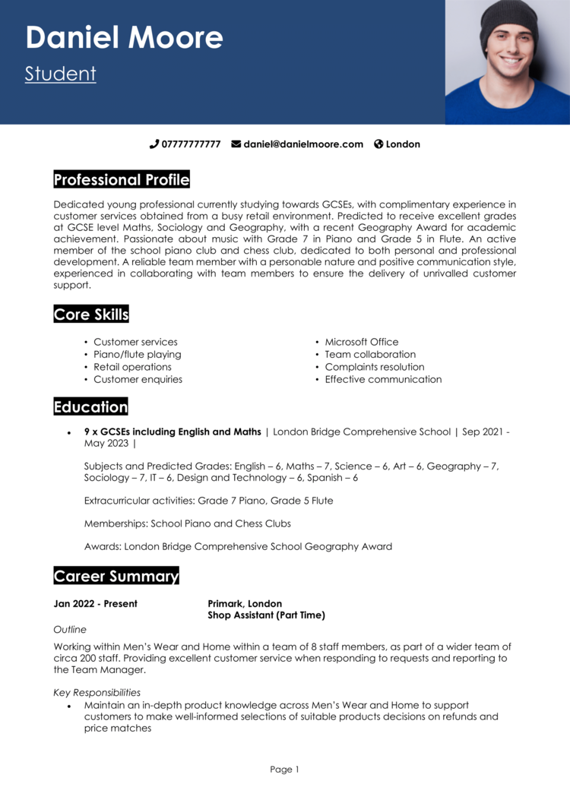

# Cover letter

**What is a Cover Letter?**

While a resume shares the technical details of your skills and work experience, a cover letter provides insight into your soft skills, attitude and goals. A cover letter introduces you and your resume to a prospective employer, demonstrates your writing ability and summarizes why you believe you are right for the position.

**Parts of a cover letter**

The cover letter should be one-page maximum, and should include the following parts:

1. **Professional heading** – this includes your professional heading from your resume, name of the company/ organization, date, and contact information.

Example



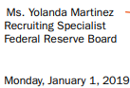

1. **Salutation/greeting** – this includes address the name of the hiring person or can also be addressed as ‘Dear Sir/Madam’ or ‘Respected Sir/Madam’.
2. **Introduction paragraph**

* Convey your goal for the letter e.g., full-time position, internship, part-time position etc.
* Indicate how you found out about the opening
* Describe why you are interested in that position at that organization, along with your background and qualifications

1. **Second paragraph**

* Describe why you are a strong candidate by expanding upon your experiences, academics, skills, goals or personal traits.
* Provide examples of how you have demonstrated the skills necessary for the job.

1. **Third paragraph**

* Tie together your overall skills and experiences with the particular position and organization.
* Demonstrate your knowledge of the skills necessary for the job.

1. **Closing paragraph**

* Re-emphasize your interest in the position and organization
* Thank them for their and consideration.
* Sign off with a professional closing phrase and your signature or typed name. Some appropriate closing phrases include *Sincerely, Best regards, Respectfully, Thank you or, With thanks.*

Example

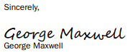

**Providing Salary information**

Some employers will ask you to include your salary history or your salary requirements when applying for a position. They do so for a variety reasons. Regardless, it`s in your best interest to give the employer the information they seek. Provide at least a salary range that meets your requirements based on research, your experience and the location. You may also state that your requirements are negotiable.

**Electronic etiquette**

* If applying by email, send a brief message about a paragraph, that explains your background and states your interest in the position. Then, attach your cover letter and resume documents.
* Always save your cover letter and resume as PDFs.

**Goal-oriented tips for your cover letter**

* Research the organization and position carefully before you start writing, so you can describe exactly why you are a good fit.
* Emphasize aspects of your background that best suit the organization and the position.
* Proofread carefully for grammar and spelling
* Keep sentences short and clear with strong action verbs
* Avoid starting sentences continuously with “I” statements
* Don`t use the same cover letter for each position. Customize each letter.