# Reported speech and its rules.

Reported speech *is when we tell someone what another person said.*

There are 2 types of speech;

Direct speech quotes the exact words spoken. While writing direct speech, we must place the words spoken in quotation marks ("...").   
 Example: She said, "I am ready."

Indirect speech or Reported speech is used to report the words spoken by someone in the past.   
 Example: She said she was ready.

# Rules to keep in mind while converting direct speech to reported speech

Rule #1

|  |  |
| --- | --- |
| **Reported Verb** | **Reported Speech** |
| **Subject** | First person (I, we) Changes according to the subject of the reported verb |
| **Object** | Second person (you) Changes according to the object of the reported verb |
| **No Change** | Third person (he, she, it, they) No change |

Rule #2

|  |  |
| --- | --- |
| **Direct Speech** | **Indirect Speech** |
| Present Simple Tense do /does V1 | Past Simple Tense  did + V1 V2 |
| Present Progressive Tense is/am/are + V4 | Past Progressive Tense was /were + V4 |
| Present Perfect Tense has /have + V3 | Past Perfect Tense had + V3 |
| Present Perfect Progressive has been /have been + V4 | Past Perfect Progressive had been + V4 |
| Past Simple Tense did + V1 V2 | Past Perfect Tense had + V3 |
| Past Perfect Tense had + V3 | Past Perfect Tense had + V3 |
| Past Perfect Progressive had been + V4 | Past Perfect Progressive had been + V4 |
| Future Simple Tense will + V1 | would + V1 |
| Future Progressive Tense will be + V4 | would be + V4 |
| Future Perfect Tense will have + V3 | would have + V3 |
| Future Perfect Progressive will have been + V4 | would have been + V4 |

Rule #3 **Changing Certain Words**

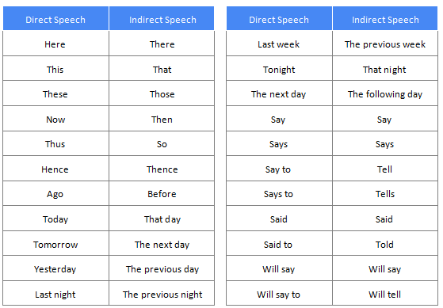

# Practice transforming direct speech into reported speech.

***Direct speech:***

She said, “Alas! My brother failed the test.”

***Reported/indirect speech:***

She exclaimed with great sorrow that her brother had failed the test.

***Direct speech:***

They said, “What a beautiful house this is!”

***Reported/indirect speech:***

They exclaimed that that house was very beautiful.

***Direct speech:***

We said to him, “Are you ill?”

***Reported/indirect speech:***

We asked him if he was ill.

***Direct speech:***

You said to me, “Have you read the articles?”

***Reported/indirect speech:***

You asked me if I had read the article.

***Direct speech:***

He said to her, “Will you go to the XYZ Radio Station?”

***Reported/indirect speech:***

He asked her if she would go to the XYZ Radio Station.

**Tips to Practice Reported Speech**

Here are some tips you can follow to become a pro in using reported speech.

* Select a play, a drama or a short story with dialogues and try transforming the sentences in direct speech into reported speech.
* Write about an incident or speak about a day in your life using reported speech.
* Develop a story by following prompts or on your own using reported speech.

# Reporting verbs.

When we want to report what people say, we use **reporting verbs**. Different reporting verbs have different patterns, for example:

*Elizabeth****complained (that) she was tired***.  
(verb + *that* clause)

*She****asked if they could stop for a rest****.*  
(verb + *if* clause)

*Simon****told her not to worry****.*  
(verb + *to*-infinitive)

*He****suggested stopping****and****having a picnic****.*  
(verb + -*ing* form)

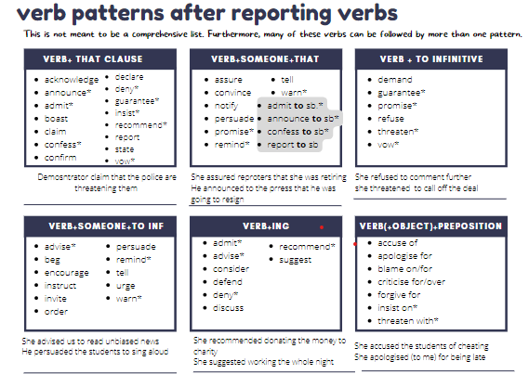

|  |  |  |
| --- | --- | --- |
|  | **SENTENCE** | **VERB** |
| 1 | Sorry I’m late. | APOLOGISE |
| 2 | I didn’t break your mobile! | DENY |
| 3 | I’ll never leave you, my love! | PROMISE |
| 4 | Don’t walk alone in this neighbourhood at  night. | WARN |
| 5 | Would you like to have dinner with me  tonight? | INVITE |
| 6 | This bag was so cool, I wish I had bought it. | REGRET |
| 7 | You ate the last piece of pie! | ACCUSE |
| 8 | I’ll shoot you if you don’t give me the money! | THREATEN |
| 9 | I won’t wear this dress, it is awful! | REFUSE |
| 10 | Remember to bring your calculators for class  tomorrow! | REMIND |
| 11 | I destroyed your new carpet, it’s my fault. | ADMIT |
| 12 | I’ll help you with all these boxes! | OFFER |
| 13 | You should try this new Japanese restaurant,  the food there is delicious. | RECOMMEND |
| 14 | Let’s take the car instead of the bus, it’s faster. | SUGGEST |
| 15 | If I were you, I’d talk to your boss. | ADVISE |
| 16 | You absolutely must see this film, it’s  amazing! | INSIST ON |