# MODAL VERBS & CONDITIONALS

Modal verbs are a part of the larger group called **auxiliary verbs**, which are verbs that can`t be used on their own. They require to be used along with another (main) verb. Modal verbs include; can, could, may, might, must, shall, should, will, would. They offer additional information about the verb that follows them. Modal verbs are used to express ability, obligation, permission, possibility, make requests and offers, and give advice. They can have more than one earning, which depends on the context they`re used in.

## Modals verbs for expressing Ability

Modals of ability are used to express the power to do something or to act in a particular way. These modals are used to express someone`s ability to do something. The modals of ability include can, could, be able to. They can also be used in negatives and questions.

1. **Can**

The modal verb “Can” helps express someone`s ability to do something in the present or future. It is used to express the speaker`s ability or permission to do something. Examples of sentences of “can” modal verb include:

* I *can* swim.
* He *can* play the piano.
* She *can* speak four languages
* We *can* go to the movies.

1. **Could**

This modal verb helps express someone`s ability to do something in the past. It is used to express the speaker`s ability or permission to do something in the past. Examples of sentences with the modal verb “could” include:

* I *could* run a mile in six minutes.
* Harry *could* solve the problem quickly.
* She *could* speak German fluently.
* They *could* go to the park.

1. **Be Able To**

This verb phrase is used to express someone`s ability to do something in the present or future. It is used to express the speaker`s ability or permission to do something. Examples of sentences with the verb phrase “be able to” include:

* I am *able to* sim
* She is *able to* play the piano
* Andrew is *able to* speak five languages
* They are *able to* go to the show

1. **Negatives**

Negative are formed by using “not”. Examples:

* I *cannot* play tennis
* She *can`t* play piano
* Tom *could not* finish his homework last night
* Jane *couldn`t* finish her project last night
* I will not *be able to* go to the function today
* Brenda won`t *be able to* go to work today

1. **Questions**

You can form questions by changing the order of the words. Examples include:

* Can you drive a motorcycle?
* Could the dog swim?
* Will James be able to bring his boots?

# Modals of Possibility

These modals express the likelihood of a situation happening. They include *may, might, could, must* and *have to.*

1. **May**

May shows possibility in the present or the future. Examples:

* *Present:* Where are my keys? They *may* be in the house.
* *Future:* She *may* go to the party tonight.

May is formal and is usually found in writing. For example;

* Side effects of this medication *may* include fever and headache.

1. **Might**

Possibility in the present or future. Examples:

* Where are my shoes? They *might* be in the car.
* I *might* go to the function tonight.

Might is less formal than may and is more common in conversation.

1. **Could**

Something is possible in the present or future. Could shows options or possibility. Examples include:

* *Present*: Where are my keys? They *could* be in the car
* *Future*: They *could* go to the party tonight

1. **Must**

Expresses certainty or the belief of certainty, from the speaker. Examples include:

* *Certain*: Everyone is wearing a jacket. It *must* be cold
* *Belief of certainty*: They were running for 2 hours. They *must* be tired. (Though it seems obvious, it is not a fact that the runners are tired.)

1. **Has/Have To**

Expresses certainty or the belief of certainty. Examples include:

* *Certain*: Everyone is wearing a jacket. It *has to* be cold
* *Belief of certainty*: They were running for 2 hours. They *have to* be tired.

## PAST POSSIBILITY

Aside from showing future and present possibilities, modal verbs sometimes show past possibilities using this structure:

Modal verb + have + past participle form of the verb, for example:

* Everyone must-have been defeated byte bad news
* Brian could have been at the bank
* Your brother may have gone home early.
* The team must have passed the test

# Modals of Necessity

The modal verbs "must", "have to" and "have got to" indicate that something is not optional, it is necessary.

1. **Must** is the strongest and most serious modal verb of the three and is most common in writing. It is unusual to use "must" in questions.

* I must study tonight in the library

1. **Have got to** is most common in informal speech. It is not used in questions.

* I have got to study tonight in the library

1. **Have to** is the most commonly used modal verb. It is useful for forming questions and negatives.

Remember! The subject and verb must agree for he/she/it subjects and the question form requires "Do/Does/Did".

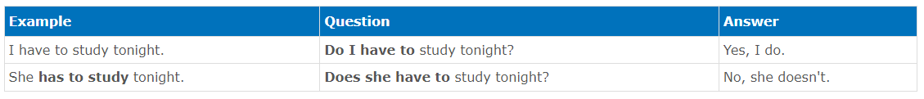

Note that: "have got to" and "have to" are modal verbs that need a simple verb to follow them. The "to" part of the modal, is not an infinitive "to".

There is only one way to express past time with these modal verbs; HAD TO - There is no past tense of must/have got to.

For example;

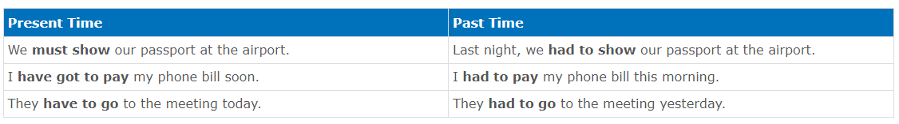

# CONDITIONALS

**What is a Conditional Sentence?**

There are always two parts to a conditional sentence

1. Beginning with "if" to describe a possible situation.
2. Describes the consequence

For example;

* *If it rains, we'll get wet*

We can also invert the two parts of a conditional sentence so that the "if" part comes second and this is especially common in questions. For example:

* What will you do if you miss the train?
* How will he finish the project if they don't have a computer?
* What happens if the students don't pass an exam?

## Different types of Conditional Sentences

There are different types of conditional sentences:

* The Zero Conditional
* The First Conditional
* The Second Conditional

**The Zero Conditional**

We apply the zero conditional to talk about permanent truths, such as scientific facts and general habits. The structure is simple:

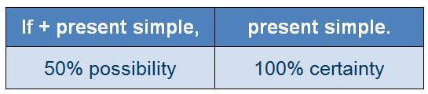

For example:

* If you **hear** water to 100 degrees, it **boils**.
* If you **eat** a lot, you **put on** weight.
* If it **doesn't rain** for a long time, the land **gets** dry.
* If we **go out** with friends, we usually **go** to the cinema.
* If **I'm** exhausted, I **go** to bed early.

**The First Conditional**

We use the first conditional to talk about a realistic situation in the present or future. The structure is as follows:

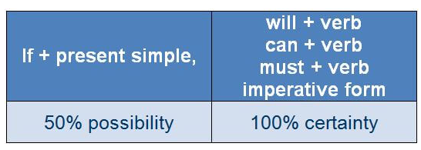

Here are some examples:

* If you**'re** free later, we **can go** walk.
* If they**'re** hungry**,** I**'ll** **make** some sandwiches.
* If you'**re not** back by 6pm, **give** me a call.
* If she **studies** hard, she'**ll do** well in the exam
* If we **arrive** late, we **must get** a taxi
* They`**ll call** if they **need** help.
* **Take** a break if you'**re** tired

Another way to make a first conditional sentence is to use "unless" which means "only if" or "except". As with "if", the word "unless" can be followed by "will" but only by the present simple. For example:

* **Unless** you **hurry up**, you won't catch the bus.
* I'll carry on doing this work, **unless** my boss **tells** me to do something else.
* We'll stay at home **unless** the weather **improves**.

**The Second Conditional**

We use second conditional to talk about improbable or impossible situations in the present or future. Here is the structure:

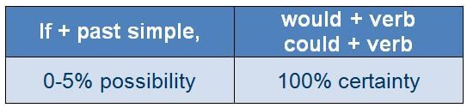

Examples:

* If I **had** more time, **I'd exercise** more.
* If I **were** rich, **I'd spend** my time traveling
* If she **saw** a dog, she **'d be** very happy
* If he **didn't have to** work late, he **could take** the kids to the movies
* What **would** you **do** it you **were** offered a job in Canada?
* You **wouldn't have to** walk everywhere if you **bought** a car

A common expression used to give advice has the second conditional structure. The expression is "**If I were you"; I'd...",** meaning 'in your situation, this is what I would do'. For example;

A: I've got a headache

B: *If I were you, I'd* take an aspirin

A: I don't understand this

B: *If I were you, I'd* ask your teacher for help

A: This order won't be delivered on time

B: *If I were you, I'd* phone the customer to let them know