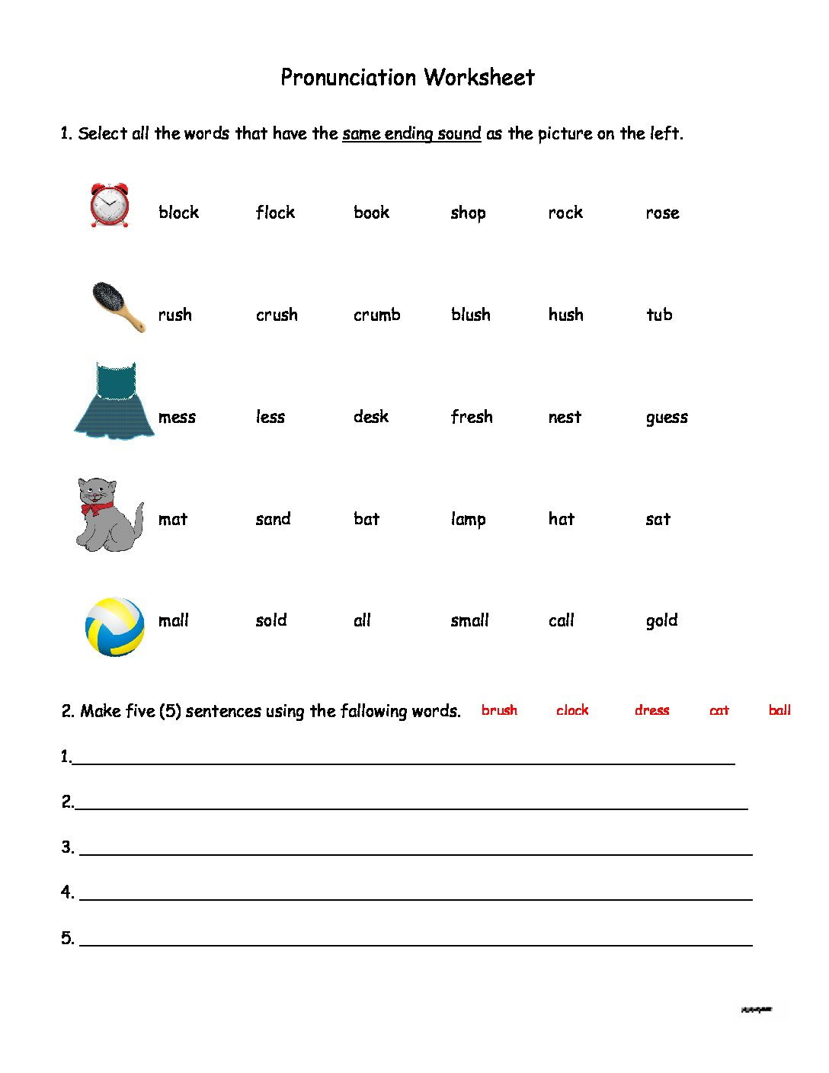

3.

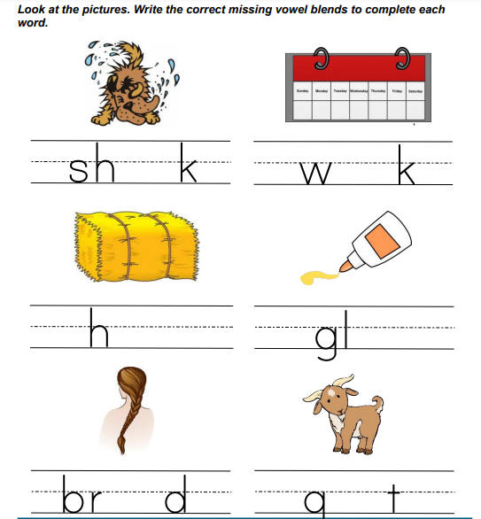

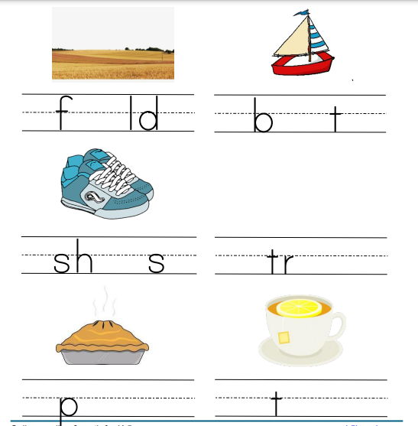

4. Match the greetings on the left with their corresponding responses on the right:

i. Good morning! a) Nice to meet you too.

ii. How are you? b) Good evening!

iii. Hi, I'm Alex. c) I'm fine, thanks. And you?

iv. Nice to meet you. d) Hi, Alex. I'm Sarah.

v. Goodbye! e) Goodbye!

5. Complete the following introductions and answer the questions.

I. A: Hi, my name is Emily. ______________?

B: I'm John. Nice to meet you, Emily!

II. A: Hello, I'm Lisa. ______________?

B: I'm Mike. How do you do, Lisa?

III. A: Hey, I'm Jessica. ______________?

B: Hi, Jessica. I'm David. Pleased to meet you!

IV. A: Good morning, I'm Tom. ______________?

B: Hello, Tom. I'm Sarah. How are you today?

6. Look at the pictures and Circle the correct vowel blend for each word:

