1. **Complete and fill in your personal and company information at a networking event**

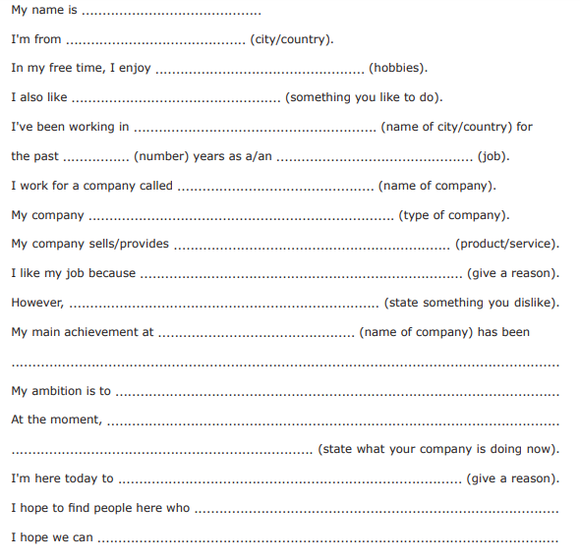

# Describing Places: My Neighborhood

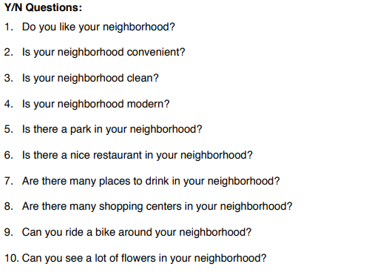

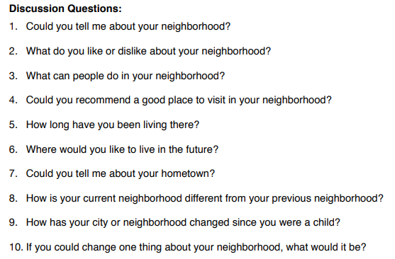

# Describing People

Instructions:

* Read the following descriptions and answer the questions that follow.
* Use appropriate vocabulary and phrases to describe people

Description I:

Maria has long, curly hair. She wears glasses and has a friendly smile. She loves to help others and is always kind to everyone.

Question 1: How would you describe Maria's hair?

Answer: _______________

Question 2: What accessories does Maria wear?

Answer: _______________

Question 3: What is one positive personality trait of Maria?

Answer: _______________

Description 2:

John has short, straight hair and blue eyes. He is tall and athletic. He enjoys playing soccer and is very competitive.

Question 1: How would you describe John's hair?

Answer: _______________

Question 2: What color are John's eyes?

Answer: _______________

Question 3: What is one activity that John enjoys?

Answer: _______________

Description III:

Emily has freckles on her face and red hair. She is creative and loves to draw. She is often seen with a sketchbook and pencil.

Question 1: Where does Emily have freckles?

Answer: _______________

Question 2: What color is Emily's hair?

Answer: _______________

Question 3: What is one hobby of Emily?

Answer: _______________

Description IV:

Samuel has brown hair and wears glasses. He is very smart and loves to read books. He is always eager to learn new things.

Question 1: What color is Samuel's hair?

Answer: _______________

Question 2: What does Samuel wear to assist his vision?

Answer: _______________

Question 3: What is one positive characteristic of Samuel?

Answer: _______________

Description V:

Lily has long, straight blonde hair. She has a great sense of humor and loves to make people laugh. She is always cheerful and friendly.

Question 1: How would you describe Lily's hair?

Answer: _______________

Question 2: What is one positive personality trait of Lily?

Answer: _______________

Question 3: What is one thing Lily enjoys doing?

Answer: _______________

# Making Appointments

Instructions:

* Read the following scenarios and answer the questions that follow.
* Use appropriate language and manners when making appointments.
* Feel free to ask your teacher for help if you need assistance.

Scenario I:

You need to meet with the school principal to discuss a matter of importance. The principal is always busy, so you need to schedule a meeting.

Question 1: Who do you need to make an appointment with?

Answer: _______________

Question 2: Write a polite and clear sentence to make the appointment.

Sentence: _______________

Scenario II:

You want to join an after-school club, but you need to meet with the club coordinator to get more information and sign up.

Question 1: Who do you need to make an appointment with?

Answer: _______________

Question 2: Write a polite and clear sentence to make the appointment.

Sentence: _______________

# Giving Directions

Instructions:

* Read the following scenarios and answer the questions that follow.
* Use appropriate language and vocabulary to give directions.

Scenario I:

Your sibling is searching for the gymnasium for a sports activity. Describe how to get there from the school entrance.

Question 1: What is your sibling looking for?

Answer: _______________

Question 2: Offer detailed directions to reach the gymnasium from the school entrance.

Directions: _______________

Scenario II:

Your neighbor wants to locate the art room for a painting class. Explain how to get there from the school cafeteria.

Question 1: What is your neighbor looking for?

Answer: _______________

Question 2: Provide explicit directions to reach the art room from the school cafeteria.

Directions: _______________